**ATTENTION ALL BUSINESSES THAT SELL OR SERVE ALCOHOL**

**Throggs Neck Community Action Partnership**

Is Sponsoring An

**Alcohol Training Awareness Program**

LEARN THE LATEST COVID-19 POLICIES AND REGULATIONS

**Tuesday, October 25, 2022**

10:30-1:00 PM

2½ hour Training Program

**Location**: Via **ZOOM**

**You must register via email to receive the online invitation**

The meeting must be accessed via **desktop** w/ a camera, **laptop** w/ a camera, and a **smartphone** (need to download the FREE app)

**Immediate Benefits**

* Improved Customer Service
* Preserve the health, safety and welfare of communities
* Comply with the Alcohol Beverage Control Laws
* Stop underage drinking and sales to intoxicated persons
* Decreased penalties for alcohol violations
* May be eligible for 10% Insurance Discount

**REGISTRATION IS REQUIRED**

For more information, for **offsite rates**,

**e-mail Dawn Insanalli:** [**dinsanalli@adapp.org**](mailto:dinsanalli@adapp.org)

**Businesses within the CB #10 service area: $15per person. For all others, *$35 per person***

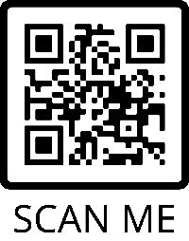

**TO REGISTER GO TO:** [**https://adapp.org/event-calendar/**](https://adapp.org/event-calendar/)

**OR SCAN THE QR CODE! (Payments will be accepted online via Stripe)**

A NYS LIQUOR AUTHORITY APPROVED

FOR THE RESPONSIBLE SERVICE, SELL, AND CONSUMPTION OF ALCOHOL