ATTENTION ALL BUSINESSES THAT SELL OR SERVE ALCOHOL

Throggs Neck Community Action Partnership
Is Sponsoring An
Alcohol Training Awareness Program
LEARN THE LATEST COVID-19 POLICIES AND REGULATIONS

Tuesday, December 20, 2022
10:30-1:00 PM
2½ hour Training Program
Location: Via ZOOM
You must register via email to receive the online invitation
The meeting must be accessed via desktop w/ a camera, laptop w/ a camera, and a smartphone (need to download the FREE app)

Immediate Benefits
- Improved Customer Service
- Preserve the health, safety and welfare of communities
- Comply with the Alcohol Beverage Control Laws
- Stop underage drinking and sales to intoxicated persons
- Decreased penalties for alcohol violations
- May be eligible for 10% Insurance Discount

REGISTRATION IS REQUIRED
For more information, for offsite rates,
e-mail Dawn Insanalli: dinsanalli@adapp.org
Businesses within the CB #10 service area: $15 per person. For all others, $35 per person
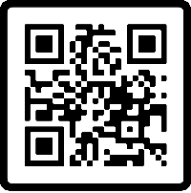
TO REGISTER GO TO: https://adapp.org/event-calendar/
OR SCAN THE QR CODE! (Payments will be accepted online via Stripe)
A NYS LIQUOR AUTHORITY APPROVED
FOR THE RESPONSIBLE SERVICE, SELL, AND CONSUMPTION OF ALCOHOL

