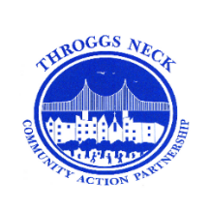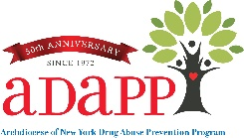

**In addition, there will be an Interactive Activity**

**“Hidden in Plain Sight” in the vestibule of the lobby.**

**6:00 pm – 6:30 pm**

**This activity is intended for adults over the age of 21.**

**Find out how to identify clues from a teen’s bedroom whether they might be experimenting with or using drugs or alcohol. See if you can find how many items are located throughout the room and hidden in plain sight.**

**Throggs Neck Community Action Partnership - TNCAP**

*Presents*

**A Community Town Hall Meeting**

**“Understanding the Effects of Substances of**

**Abuse and Behaviors on the Adolescent Brain”**

**Keynote Speaker: Dr. Stephen Dewey**

***Neuroscientist, Research Professor, and President, Addiction Educators, LLC***

**Followed by a Q &A Panel Discussion**

**Hear from experts in our community representing Community Board 10, Substance Prevention, Law Enforcement, Education, and the Office of the Bronx DA and others.**

**Visit our resource table for free prevention materials.**

**Thursday, March 2, 2023**

**Interactive Activity - 6:00 pm - 6:30 pm**

**Presentation & Panel Discussion - 6:30 pm - 8:00 pm**

**PS 72 - Auditorium**

**2951 Dewey Avenue, Bronx, NY 10465**

***Light refreshments will be served.***

**The event is free, to register you can use the QR code or click** [**here**](https://adapp.org/event/tncap-community-town-hall-meeting-march-2-2023/)**.**

**If you need further assistance registering, please contact**

**Dawn Insanalli, at 718-904-1333 Ext. 16**

**dinsanalli@adapp.org**

