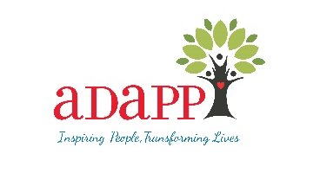
ADAPP Employment Benefits

- Competitive Salary
  - Annual step increase based on years of service
- Generous Time Off Package -
  - 15 to 40 vacation days (depending on position)
  - 8 PTO (personal/sick) days
  - 11 legal holidays
  - Christmas break
  - Easter break
  - 3 additional holidays (Day after Thanksgiving, Holy Thursday, Good Friday)
- Benefits
  - Medical Coverage
  - Dental Coverage
  - Vision Coverage
  - Life Insurance
    - Basic Life Insurance- 1 year salary paid by employer
    - Supplemental- Optional out of pocket for employee
  - Access to AFLAC insurance discounts
  - Tax Deferred Annuity
  - P&A
    - Flexible Spending Account
    - Commuter Benefits
- Pension Benefits- Employer contributes between $6,370-$11,715 a year
(fully vested after 5 years of service)
- Training & Professional Development
  - Clinical supervision towards LMHC and LCSW
  - Structured individual and group supervision
  - Access to a vast training platform and specialized training sessions with continuing education credits to maintain professional licensure (LMSW, LCSW, LCSW-R, LMHC, CPP)
  - Employee wellness programs and health content
  - Therapy tools for mental health professionals
    - Worksheets, activities, videos and articles on various metal wellness topics
- Participation in the Advisory Committee to advocate for staff needs
- Participation in the annual staff survey to provide feedback

